Notes on the original Hto lines versus the new, recommended Hto Starter chromosome.
After the introduction of the MiMIC system, we remodeled the original Hto-WP vector by adding flanking attP sites, so that it would be compatible with RMCE plasmids that are designed by the community for MiMIC (below).
We also modified the Minos right inverted repeat (IR). This region contains two natural polyA sites for Minos transposase, and thus a fraction of all transcripts proceeding through Minos will be truncated there. The truncated transcripts can express an unfused mCherry RFP that is uniformly distributed in the cytoplasm with a slightly higher concentration in the nucleus. The ratio of unfused RFP to the intended Hto fusion protein varies among the different inserts.
To address this, we mutated both polyA sites, changing AATAAA to AACAAA in each case. This greatly reduced the appearance of unfused RFP as judged by Western blot and by microscopy.
-------------
New version of Hto with cassette exchange and improved read-through:
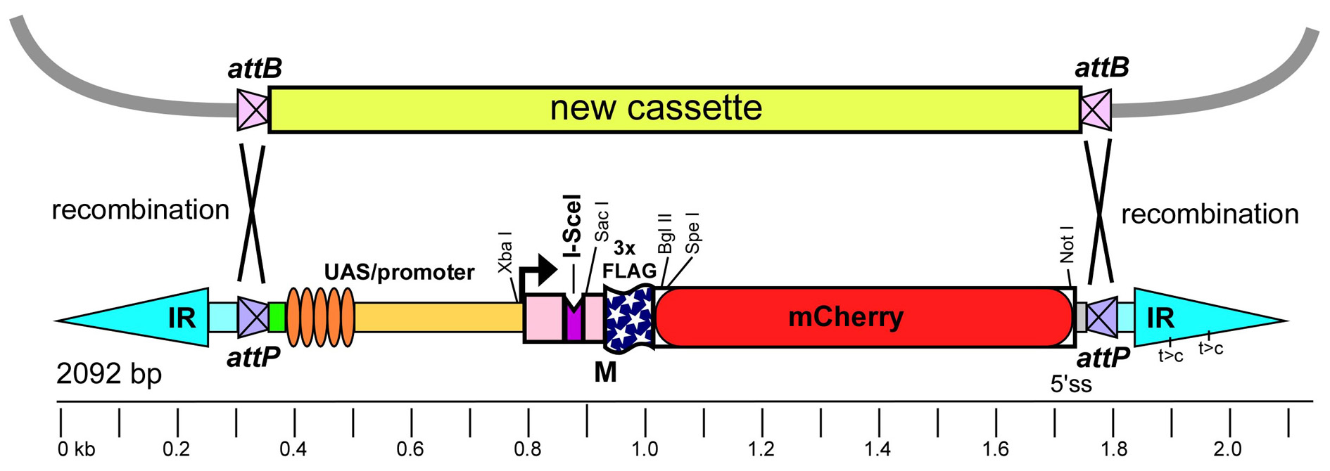
--------------
The new construct was hopped, and two inserts on the X chromosome (RENX05 and RENX20) were recovered that do not cause eye or wing phenotypes upon GAL4 expression. (REN = RFP-positive, eyes normal with GMR). The two inserts were recombined to yield the Starter chromosome (RENX05, X20). This Starter was tested in a phenotypic screen, and yields new hops to autosomes at a rate of 21% after one heat shock induction of the standard Minos transposase construct.
RENX05 lies at X: 7,076,138 in the minus orientation, within CG9650.
RENX20 insertion site was not yet identified. We see roughly 14% recombination between X05 and X20.

Nomenclature:
We named the original version of Hto as Mi[Hto-WP] for "Wild type PolyA". This is used in the GenBank record JN049642 and the Genetics paper Singari et al. 2014. This is the version present in all the lines submitted May 2014 (apart from the new Starter element).
For simplicity, the new version (with the attP sites and mutated PolyA signals) will just be called Mi[Hto], since we do not intend to make any more modifications.

